Dust, Humidity, Temp (DTH) Monitoring Device.

Introduction:
Dust, Humidity, Temp (DTH) Device are measuring of Dust, Humidity, Temp of that room/location and display in monitor/LCD Display by Wi-Fi communication. Measured value is store in excel format in storage device. So, we can check value for reference and we can see current measured value in Mobile / Laptop / PC anywhere by provided Link. DTH Device is basically embedded system. If any reason Power cut, then system is automatically ON and show measured value on monitor/LCD Display automatically. If measure vale in range than it shows value in GREEN color if any measure value of any parameter is out of range, then that measure value show in RED color. So, we can monitor that which location is measure value out of range and take precaution.

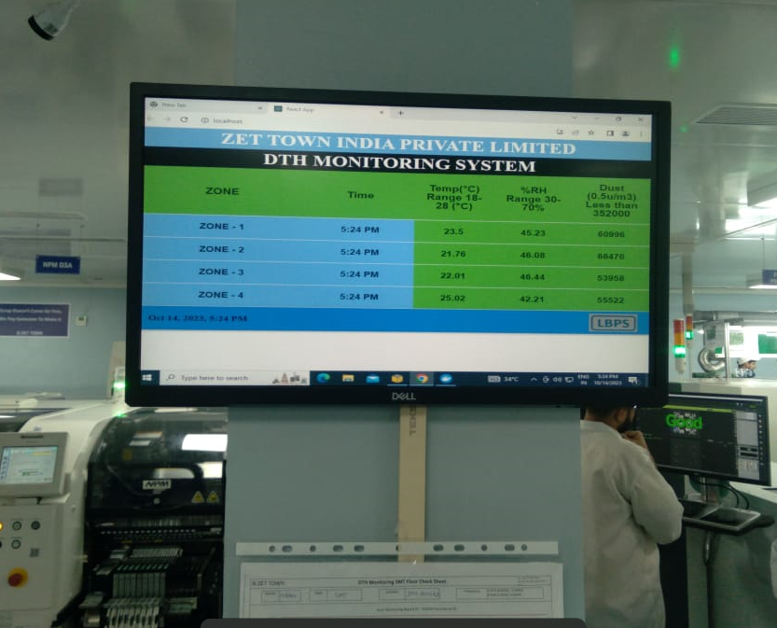

Sensor Device:
DTH Sensor device is measure current value of Dust, Temperature, Humidity. When ON the power then PWR LED is on and show DTH Sensor device is healthy mode.
If measure vale is in range, then its DUST, HWM, TEMP indication is not ON if any measure value of any parameter is out of range, then that LED indicator glow in RED color with sound/Buzzer. So, we can monitor that which parameter is out of range and take precaution.
One dedicated router connection and one IP address free from security is required for communication of DTH Monitor device with DTH controller unit. both will be provided by the customer. Each sensor unit required one 3 Pin Socket of 230VAC@ 5 amp.
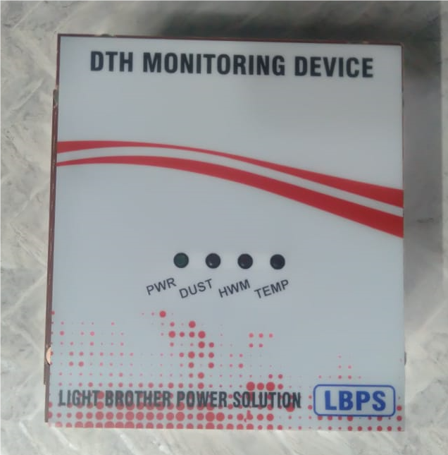

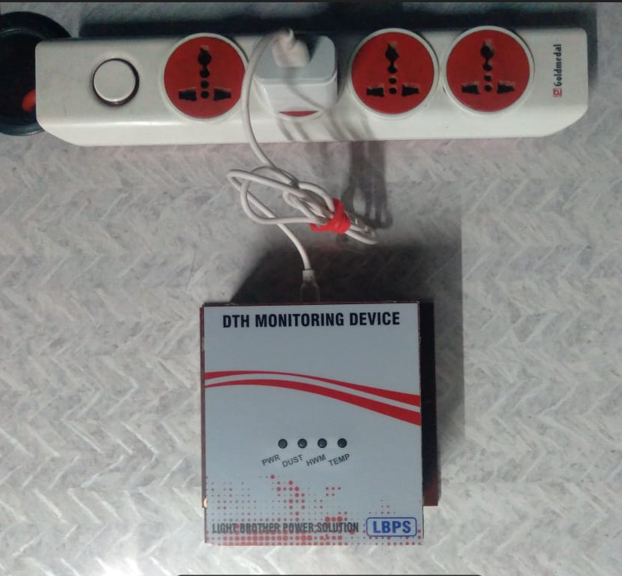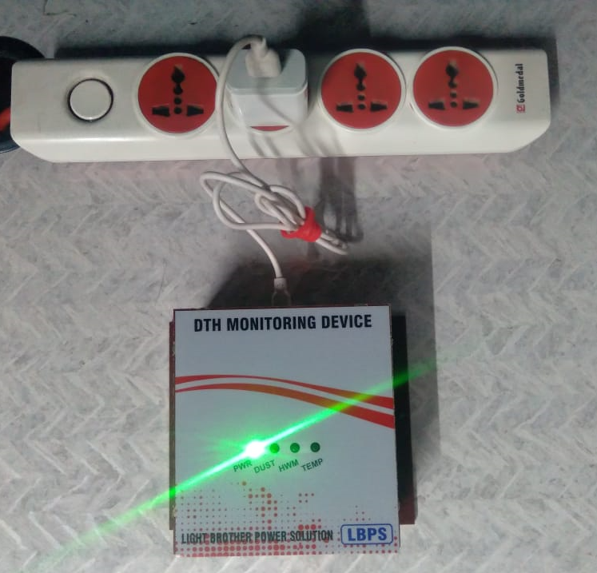

Controller unit with display:
DTH Controller can receive data of 1Nos to 8Nos DTH Sensor device by Wi-Fi and show in monitor/LCD Display. Single phase 230VAC and Ethernet wire required for Controller unit and its will be interface Monitor / LCD Display by BGA Cable. Current value of Dust, Temperature, Humidity, Time and location of DTH Monitoring device are show in monitor / LCD display by controller unit If measure vale in range than it shows value in GREEN color if any measure value of any parameter is out of range, then that measure value show in RED color. So, we can monitor that which location is measure value out of range and take precaution.

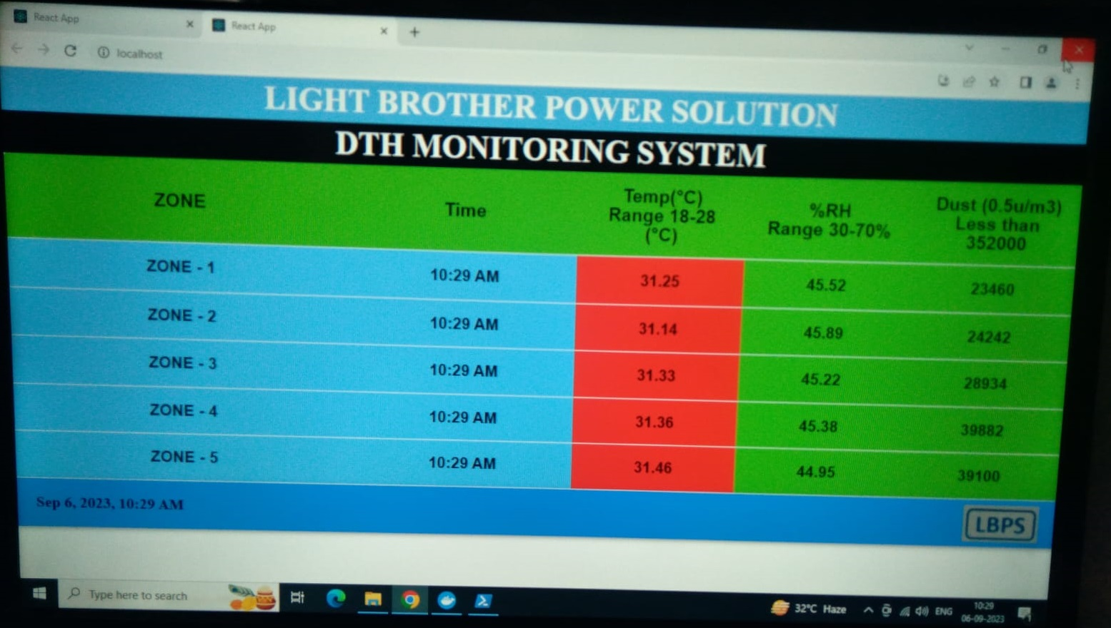

We will provide one link to customer for monitor of current measure value of Dust, Temperature and Humidity of that location/Floor. Customer can check current status of DTH measure value from anywhere in Laptop/ PC / Mobile by provided link.

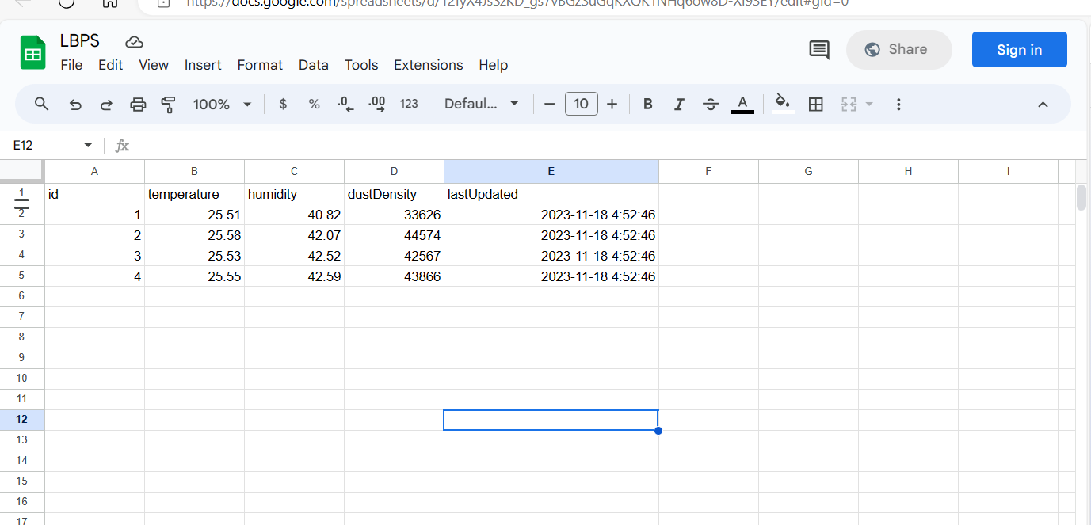

THANKS

